MEDICAL DIAGNOSIS
CENTER (MDC)
PROJECT DOCUMENTATION
A ServiceNow-based diagnostic management application for
patient records, test appointments, and medical reports.

1. Introduction

Project Title: Medical Diagnosis Center (MDC)
Platform: ServiceNow Service Portal
Team Members: G.Nikhila

Medical Diagnosis Center (MDC) is a web-based application developed on the ServiceNow platform to organize important activities carried out by a diagnostic center. The application brings together diagnostic test information, patient details, appointment records, and medical reports in a single service portal. It provides a structured way to maintain information and follow appointment progress, while different user roles support the responsibilities of administration, reception, patients, and laboratory staff.
The project was developed to demonstrate how ServiceNow's portal components, custom tables, server-side scripts, business rules, and access configuration can be combined to support a practical service workflow. The current implementation focuses on the core process of selecting a diagnostic test, submitting an appointment, tracking its status, and accessing a related report.

2. Project Overview

2.1 Purpose
The main purpose of MDC is to provide a centralized application for managing the information and workflows associated with diagnostic services. In a diagnostic center, test details, patient records, appointments, and reports are closely related. Keeping these records in separate places can make it harder to follow the progress of a booking or locate the relevant report. MDC connects these activities through related ServiceNow records and dedicated portal pages.
The system allows users to view available diagnostic tests, submit booking details, review appointment status, and access report information through the portal. On the administrative side, the configured roles and application tables support the management of diagnostic data and appointment workflows. The project also demonstrates the use of server-side automation to create a related medical report record when an appointment reaches the configured Completed status. The overall goal is to improve the organization and visibility of diagnostic-center information and provide a foundation that can be extended with additional operational capabilities.

2.2 Key Features
- Diagnostic test catalogue containing configured test names, descriptions, pricing, duration, preparation instructions, and active status.
- Test-booking page for submitting appointment details through the Service Portal.
- Appointment management with patient and test references, booking information, and status tracking.
- Patient record management for storing relevant identity and contact details.
- Medical report records linked to the corresponding appointment.
- Business Rule automation to create a report record when an appointment reaches the configured Completed status.
- Portal pages for viewing appointments and medical reports, with a configured print/download workflow for report access.
- Role-based access structure for administrators, patients, receptionists, and laboratory technicians.
- Administrative interface for reviewing and maintaining application information.

3. Architecture
MDC follows the native ServiceNow application architecture. The portal interface, application logic, record storage, and access configuration are hosted within the ServiceNow instance. The components work together to present information to users, process form submissions, maintain related records, and automate selected workflow actions.

3.1 Frontend
The frontend is built with ServiceNow Service Portal pages and widgets. The portal provides navigation to the home page and test catalogue, booking form, appointment view, medical reports, and administrative functions. Widget templates define the displayed content, while client-side scripts handle user interactions and communicate with the server-side portion of the widget when data must be retrieved or submitted.
The interface is organized around the main tasks performed by each user group. This allows patients to use the booking and report pages, while authorized staff can access the functions relevant to their operational responsibilities.

3.2 Backend and Application Logic
Server-side widget scripts handle application requests and interact with the custom tables. GlideRecord is used to retrieve records, create new entries, and access related information. The appointment workflow stores booking details and status values, while a Business Rule performs the configured report-record creation when an appointment reaches Completed.
The logic depends on correct table names, internal field names, reference fields, and stored choice values. These must remain consistent across widget scripts, Business Rules, and table configuration so that records can be retrieved and updated correctly.

3.3 Database and Data Relationships
The core data is stored in four custom ServiceNow tables:
Table | Purpose | Key information
Diagnostic Test  `x_2193703_medica_0_diagnostic_test` | Maintains the diagnostic services offered. | Test name, description, price, duration, preparation instructions, active status.
Patient  `x_2193703_medica_0_patient` | Maintains patient details used by the application. | Full name, date of birth, email, phone number, active status.
Appointment  `x_2193703_medica_0_appointment_table` | Records requests and tracks appointment progress. | Patient reference, test reference, date/time, booking date, status.
Medical Report  `x_2193703_medica_0_report_table` | Stores report information associated with an appointment. | Appointment reference, report status, report details, release information.

Reference fields link appointments to the relevant patient and diagnostic test, and link a medical report to its appointment. These relationships help maintain consistency and allow the portal to display information associated with the correct record.

4. Setup Instructions

4.1 Prerequisites
- Access to the ServiceNow development instance and permission to open the relevant application configuration.
- Appropriate permissions to view or edit custom tables, Service Portal pages and widgets, Business Rules, roles, and access controls.
- The MDC tables, portal components, roles, and server-side scripts available in the target instance.

4.2 Configuration Steps

Sign in to the ServiceNow instance
- Open the relevant application scope and confirm the custom table prefix is `x_2193703_medica_0`.
- Verify that the Diagnostic Test, Patient, Appointment, and Medical Report tables exist and contain the required fields and reference relationships.
- Confirm the roles `mdc_admin`, `mdc_patient`, `mdc_receptionist`, and `mdc_lab_technician` are configured and assigned to suitable test accounts.
- Check that the portal pages and widgets for test browsing, booking, appointments, reports, and administration are available.
- Review the Business Rule and verify its table, conditions, and Completed status value.
- Open the Service Portal and test the primary workflows using role-appropriate accounts.
- MDC is hosted within ServiceNow. The current implementation is accessed through the instance and does not require separate local frontend or backend startup commands.

5. Folder Structure and Application Organization
The application's components are organized as configuration records within ServiceNow. Each component has a defined responsibility in presenting the portal, processing requests, storing information, or controlling access.

Component | Responsibility
Service Portal Pages | Provide the main views and navigation for the catalogue, booking, appointments, reports, and administration.
Service Portal Widgets | Contain the page template, client-side interactions, and server-side scripts used to display and process data.
Custom Tables | Store diagnostic tests, patients, appointments, and medical reports.
Business Rules | Run server-side logic when configured record conditions are met, including report-record creation on appointment completion.
Roles and Access Controls | Define user permissions and help restrict access to relevant application functions and records.
UI Actions | Provide form-level actions on records where configured, such as report-related actions.

Keeping these responsibilities separate makes it easier to identify where a change belongs. For example, display changes are generally made in a portal page or widget, data changes are handled through table configuration and server-side scripts, and automatic actions are reviewed in the relevant Business Rule.

6. Running the Application
To access the application and verify its main workflows:
- Sign in to the ServiceNow instance with an authorized user account.
- Open the configured MDC Service Portal through its portal URL or the portal preview option in the instance.
- Navigate to the diagnostic test catalogue and open the test-booking page.
- Submit a test booking and check the resulting appointment record.
- Review the appointment status and test the configured completion workflow.
- Open the medical reports page and verify that the related report information is displayed.
- Test report printing/download and role-specific access with the appropriate user accounts.
- If a page does not display expected information, verify the portal page and widget configuration, the active application scope, the table and field names used in the scripts, and the user's access permissions.

7. API and Functional Interface Documentation
The application interfaces are implemented through Service Portal widgets and ServiceNow server-side logic. The following table describes the main functional operations and the records they work with.

Functional operation | Input / trigger | Processing and result
View Diagnostic Tests | The user opens the test catalogue. | The widget retrieves active diagnostic test records and displays the configured test details.
Submit Appointment | The user submits the booking form. | Server-side logic processes the submitted values and creates an appointment record with the applicable patient/test references and status.
View Appointments | The user opens the appointment page. | The page retrieves appointment records for the relevant user context and displays booking details and status.
Create Report Record | Appointment reaches the configured Completed status. | The Business Rule creates a report record linked to the appointment, using the configured demonstration report content.
View Medical Reports | The user opens the medical reports page. | The widget retrieves relevant report records and displays the report information available to that user.
Print / Download Report | User invokes the configured report print/download action. | The portal workflow prepares the report for printing or saving, subject to the behavior of the configured page and browser.

Data Processing
The portal widgets use server-side scripts to access ServiceNow records. GlideRecord queries must use the correct table name and internal field names. Submitted values should be validated before records are inserted or updated, and queries that return patient-related information should be restricted to the intended user context.

8. Authentication and Authorization
Access to MDC begins with signing in to the ServiceNow instance. Once authenticated, the available application functions depend on the roles assigned to the user and the access controls configured for the application.

Role | Intended responsibilities
`mdc_admin` | Manage diagnostic test information, appointments, reports, and application access configuration.
`mdc_patient` | Use patient-facing functions such as booking tests and viewing relevant appointments and reports.
`mdc_receptionist` | Support patient registration and appointment administration.
`mdc_lab_technician` | Support laboratory workflow activities and report-status updates.

Role-based visibility should be supported by server-side access controls. Patient-specific records must not be exposed solely on the assumption that users will navigate through the correct portal page. Queries, record operations, and access-control rules should be reviewed to ensure users cannot retrieve another patient's information by changing an input or record identifier.

9. User Interface
The Service Portal is designed around the tasks users need to complete, with separate pages for test discovery, appointment handling, report access, and administration.

9.1 Home Page
The home page acts as the entry point to the MDC portal. It directs users to the available diagnostic services and the main application sections.

9.2 Diagnostic Test Catalogue
The catalogue presents the diagnostic tests configured in the system. Depending on the fields enabled for display, users can review details such as test name, description, price, duration, and preparation instructions before making a booking.

9.3 Book a Test
The booking page collects the information required to create an appointment. The submitted details are processed by the server-side logic and stored in the Appointment table with references to the relevant patient and diagnostic test.

9.4 My Appointments
This page allows users to review appointment details and follow the configured status of a booking. It supports visibility into the progress of the request without requiring users to search through the underlying table records.

9.5 Medical Reports
The medical reports page displays report information associated with the relevant appointment. It also provides the configured report print/download workflow, allowing users to prepare a report for printing or saving through the browser.

9.6 Admin Dashboard
The administrative area is intended for authorized users who need to review and manage application information. Access to administrative functions should remain restricted to the appropriate role.

10. Testing
The current application was checked through manual functional testing in the ServiceNow instance. Testing focused on whether the main pages, record operations, status changes, and role-based workflows behaved as expected.

Functional Test Coverage
Test area | Verification performed
Diagnostic catalogue | Checked that configured test records could be retrieved and displayed in the portal.
Appointment booking | Submitted booking information and checked that an appointment record was created with the expected references and values.
Appointment status | Reviewed status updates and checked that the configured Completed value triggered the report-creation workflow.
Report creation | Verified that a report record was created and linked to the corresponding appointment.
Portal access | Reviewed the main portal pages using accounts with relevant roles.
Report access | Checked report display and the available print/download workflow.
Date and time | Identified a mismatch between the selected appointment time and the displayed or stored time.

11. Screenshots or Demo
The MDC application can be demonstrated by signing in to the configured ServiceNow instance and opening the Service Portal.

ServiceNow Instance: https://dev416049.service-now.com

The following screenshots illustrate the implementation of the Medical Diagnosis Center (MDC) application in ServiceNow.

Figure 1.Patients Table :
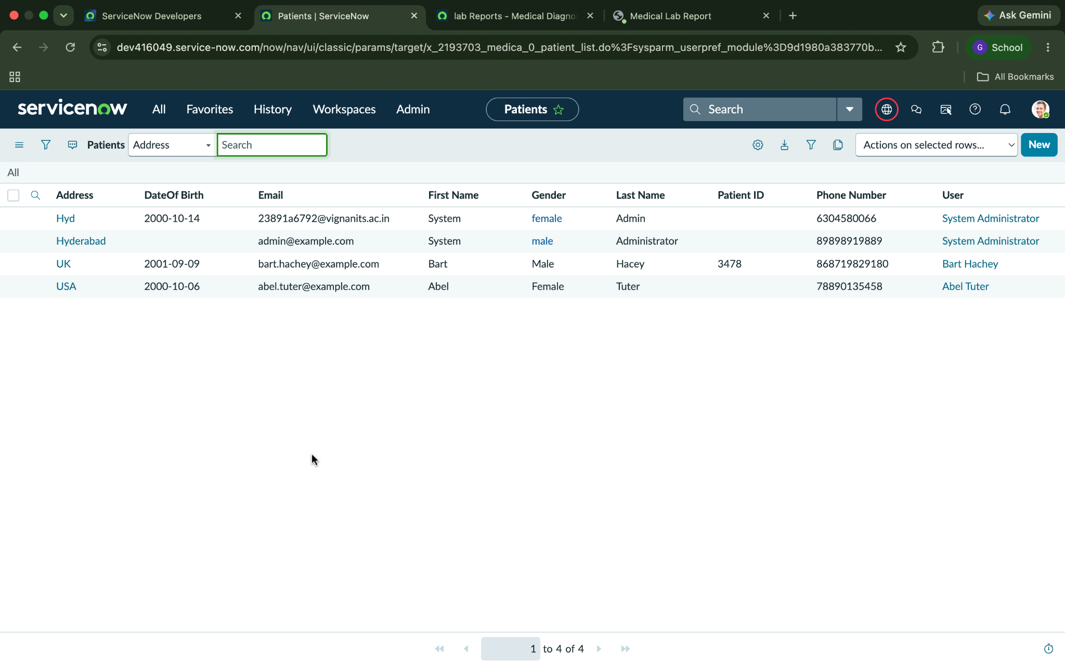

Figure 2. Appointment Table :
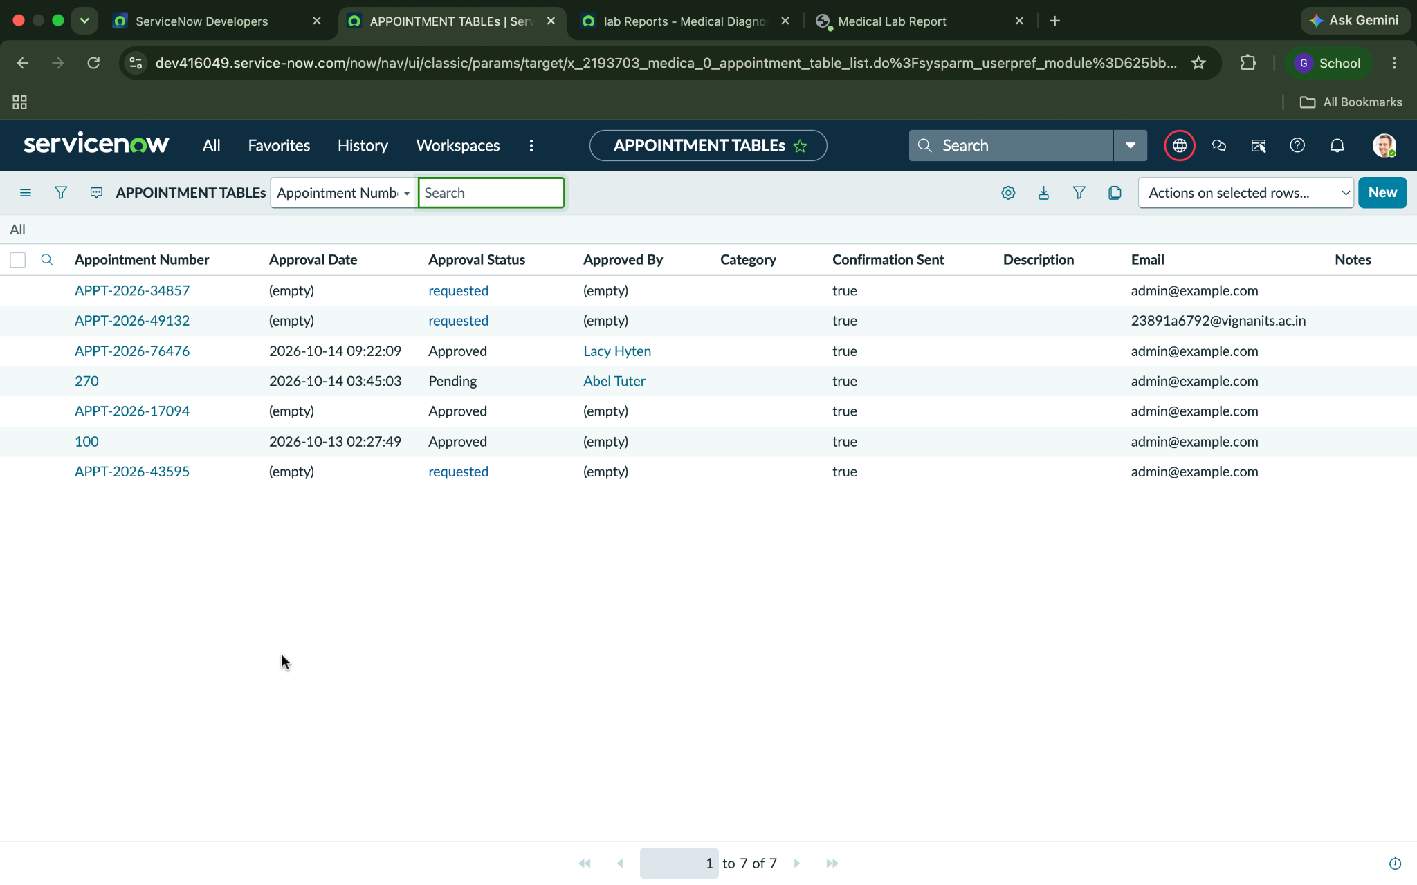

Figure 3. Diagnostic Test Table :
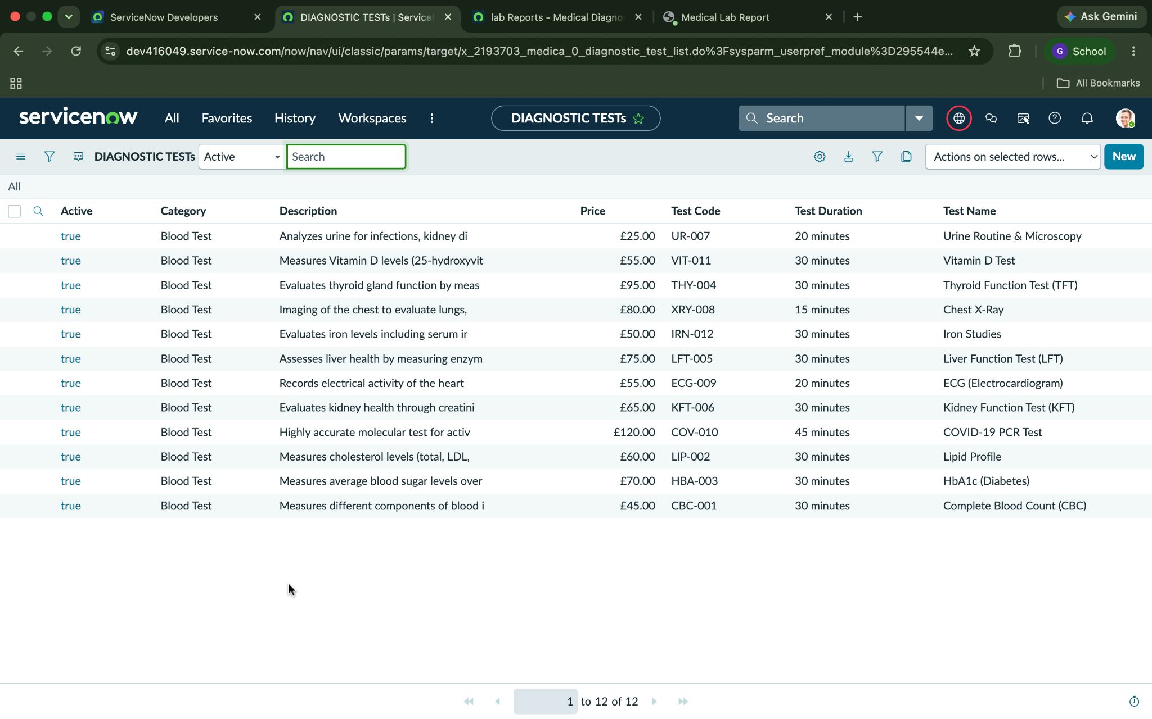

Figure 4. Report Table :
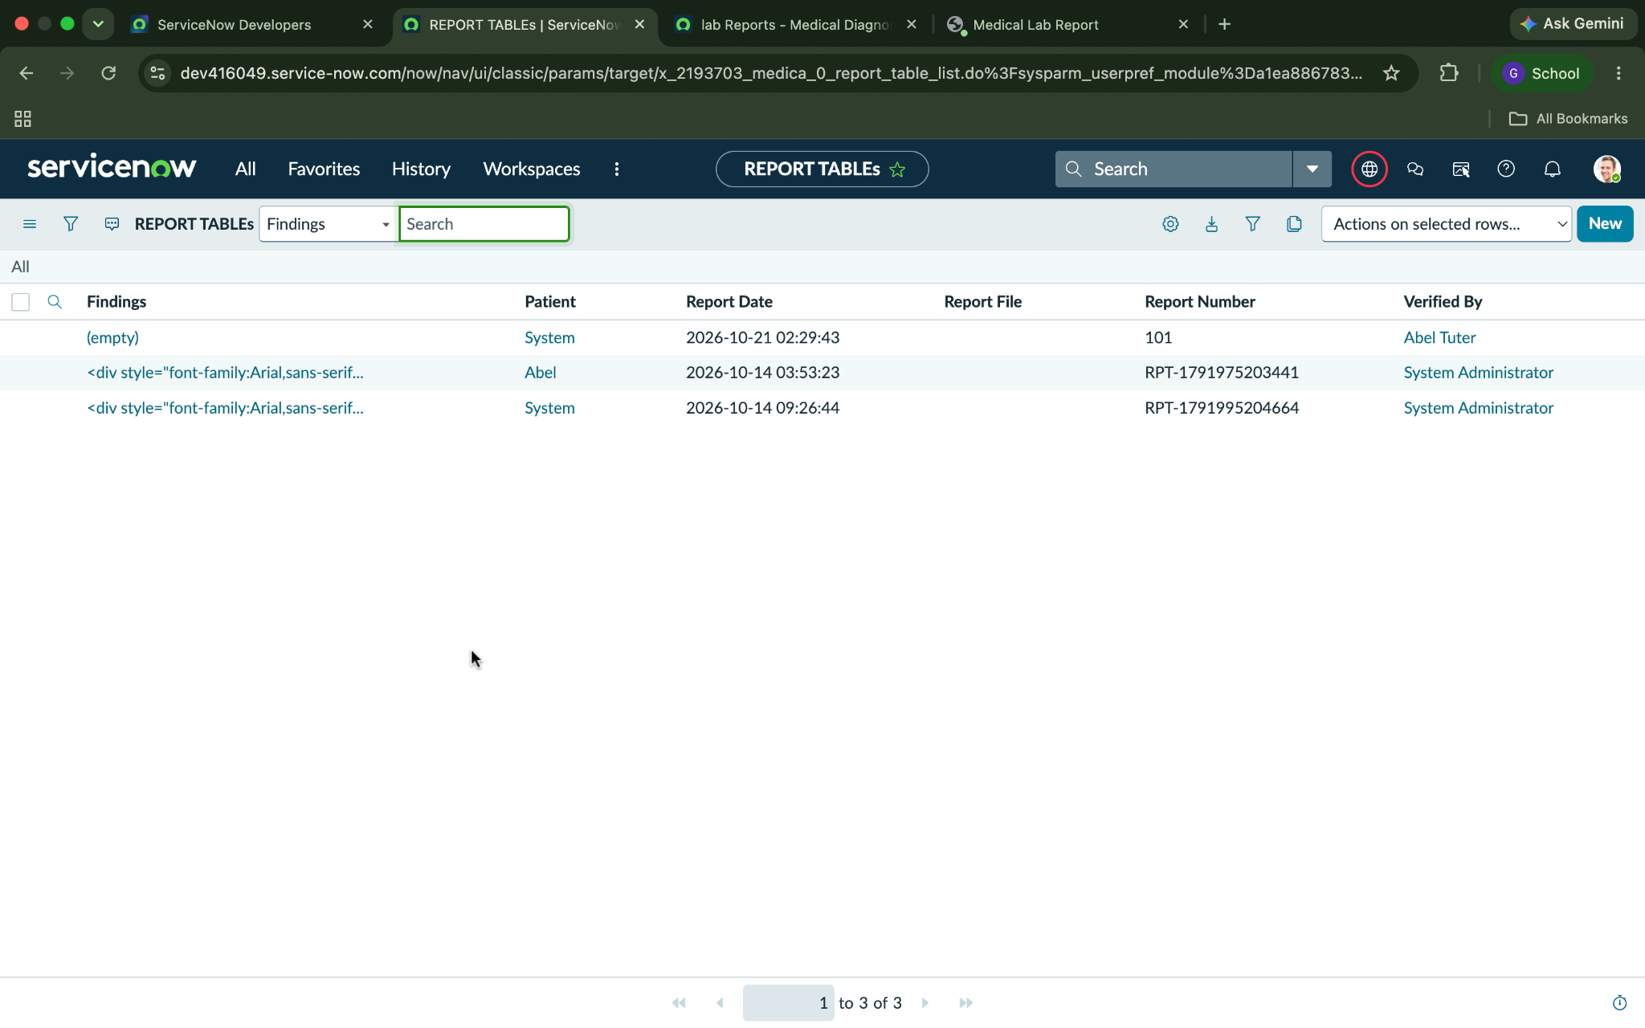

Figure 5. MDC Home
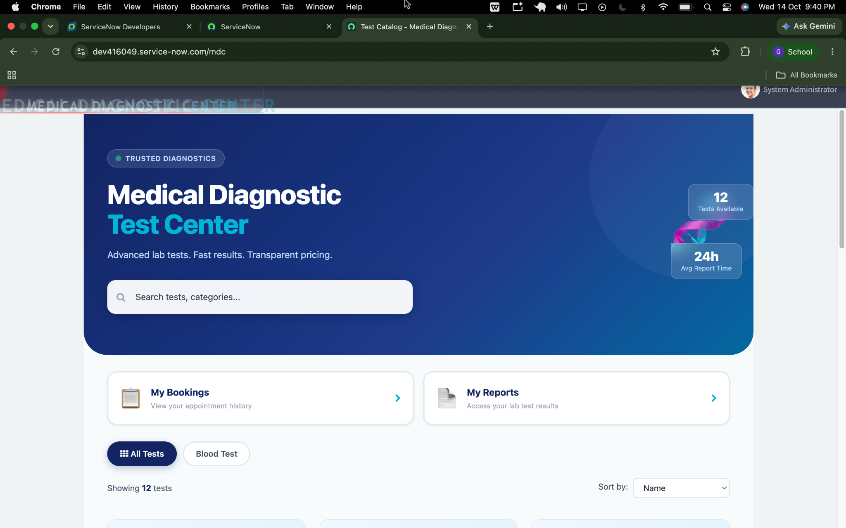

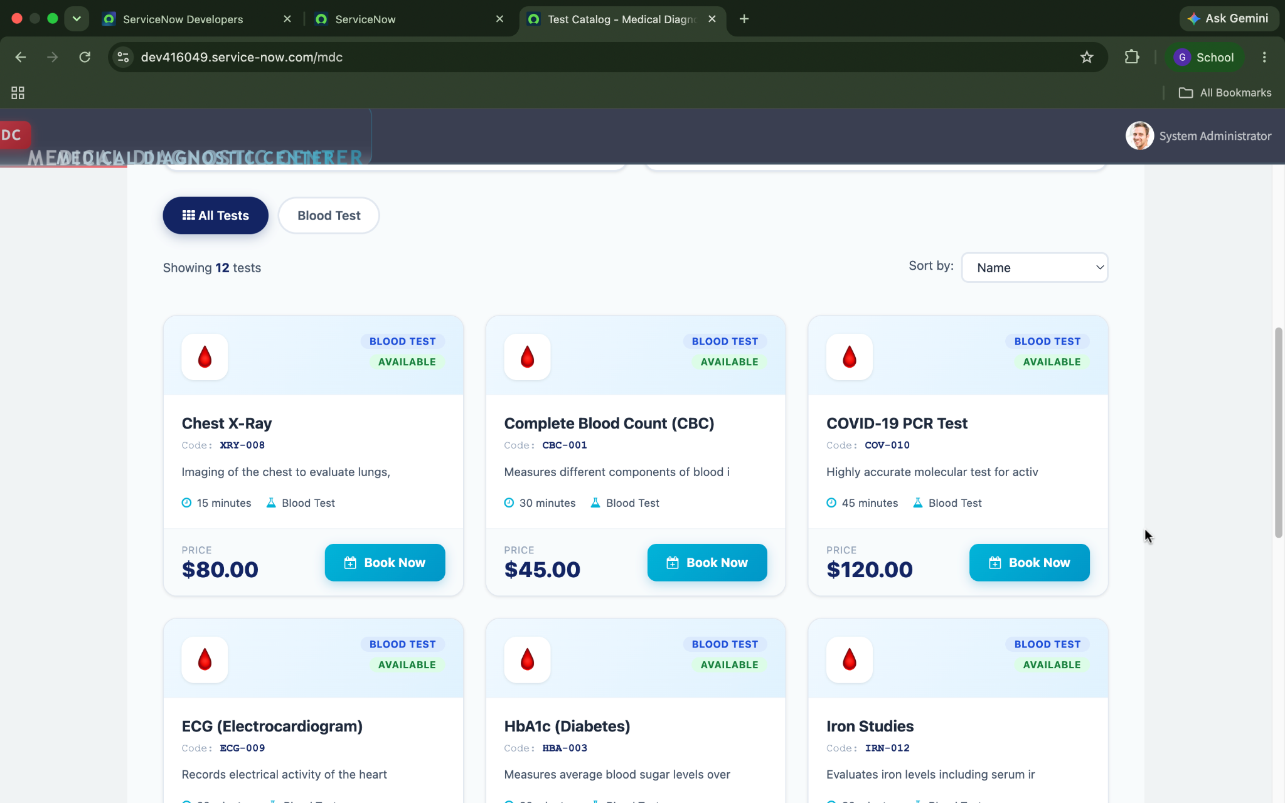

Figure 6. Book a Test page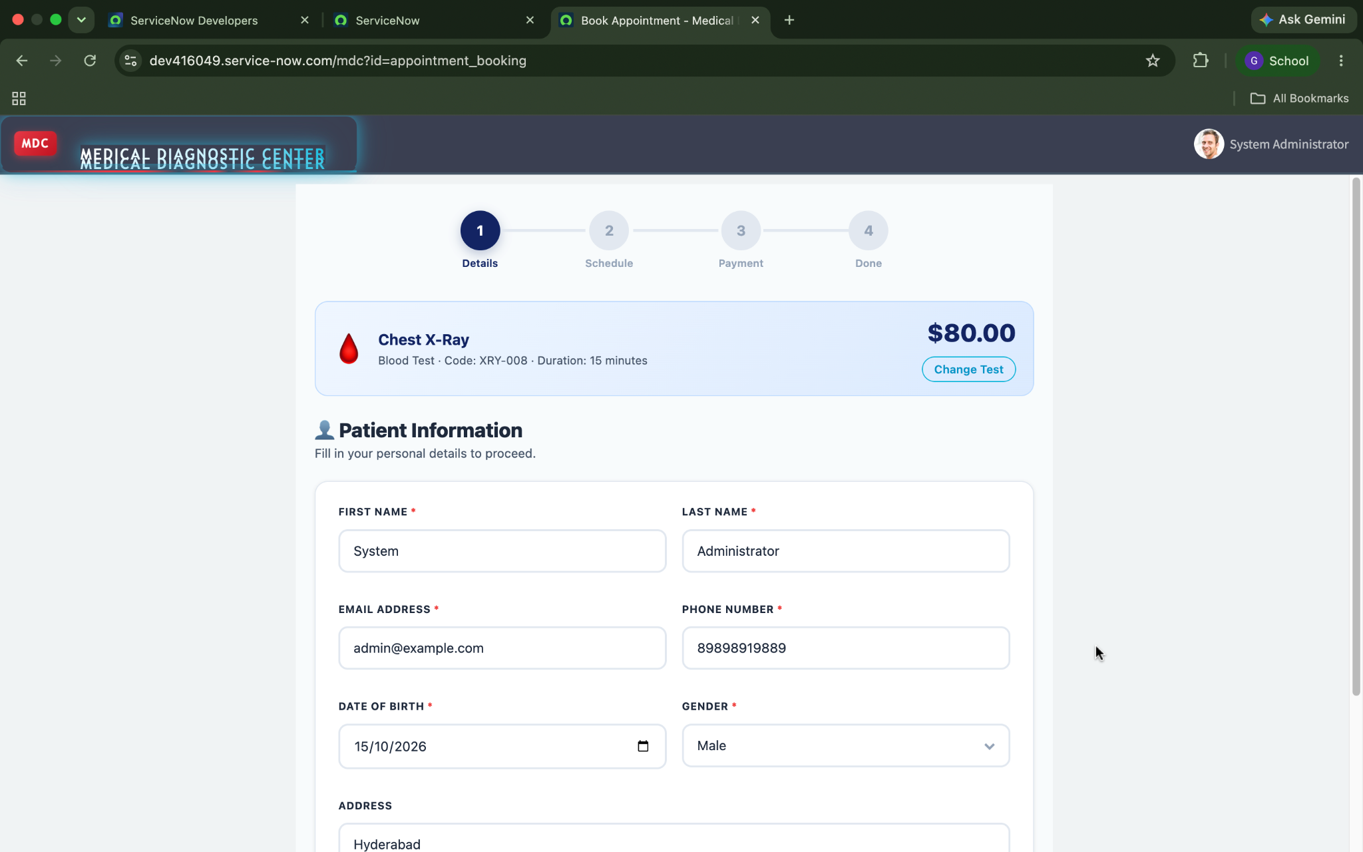

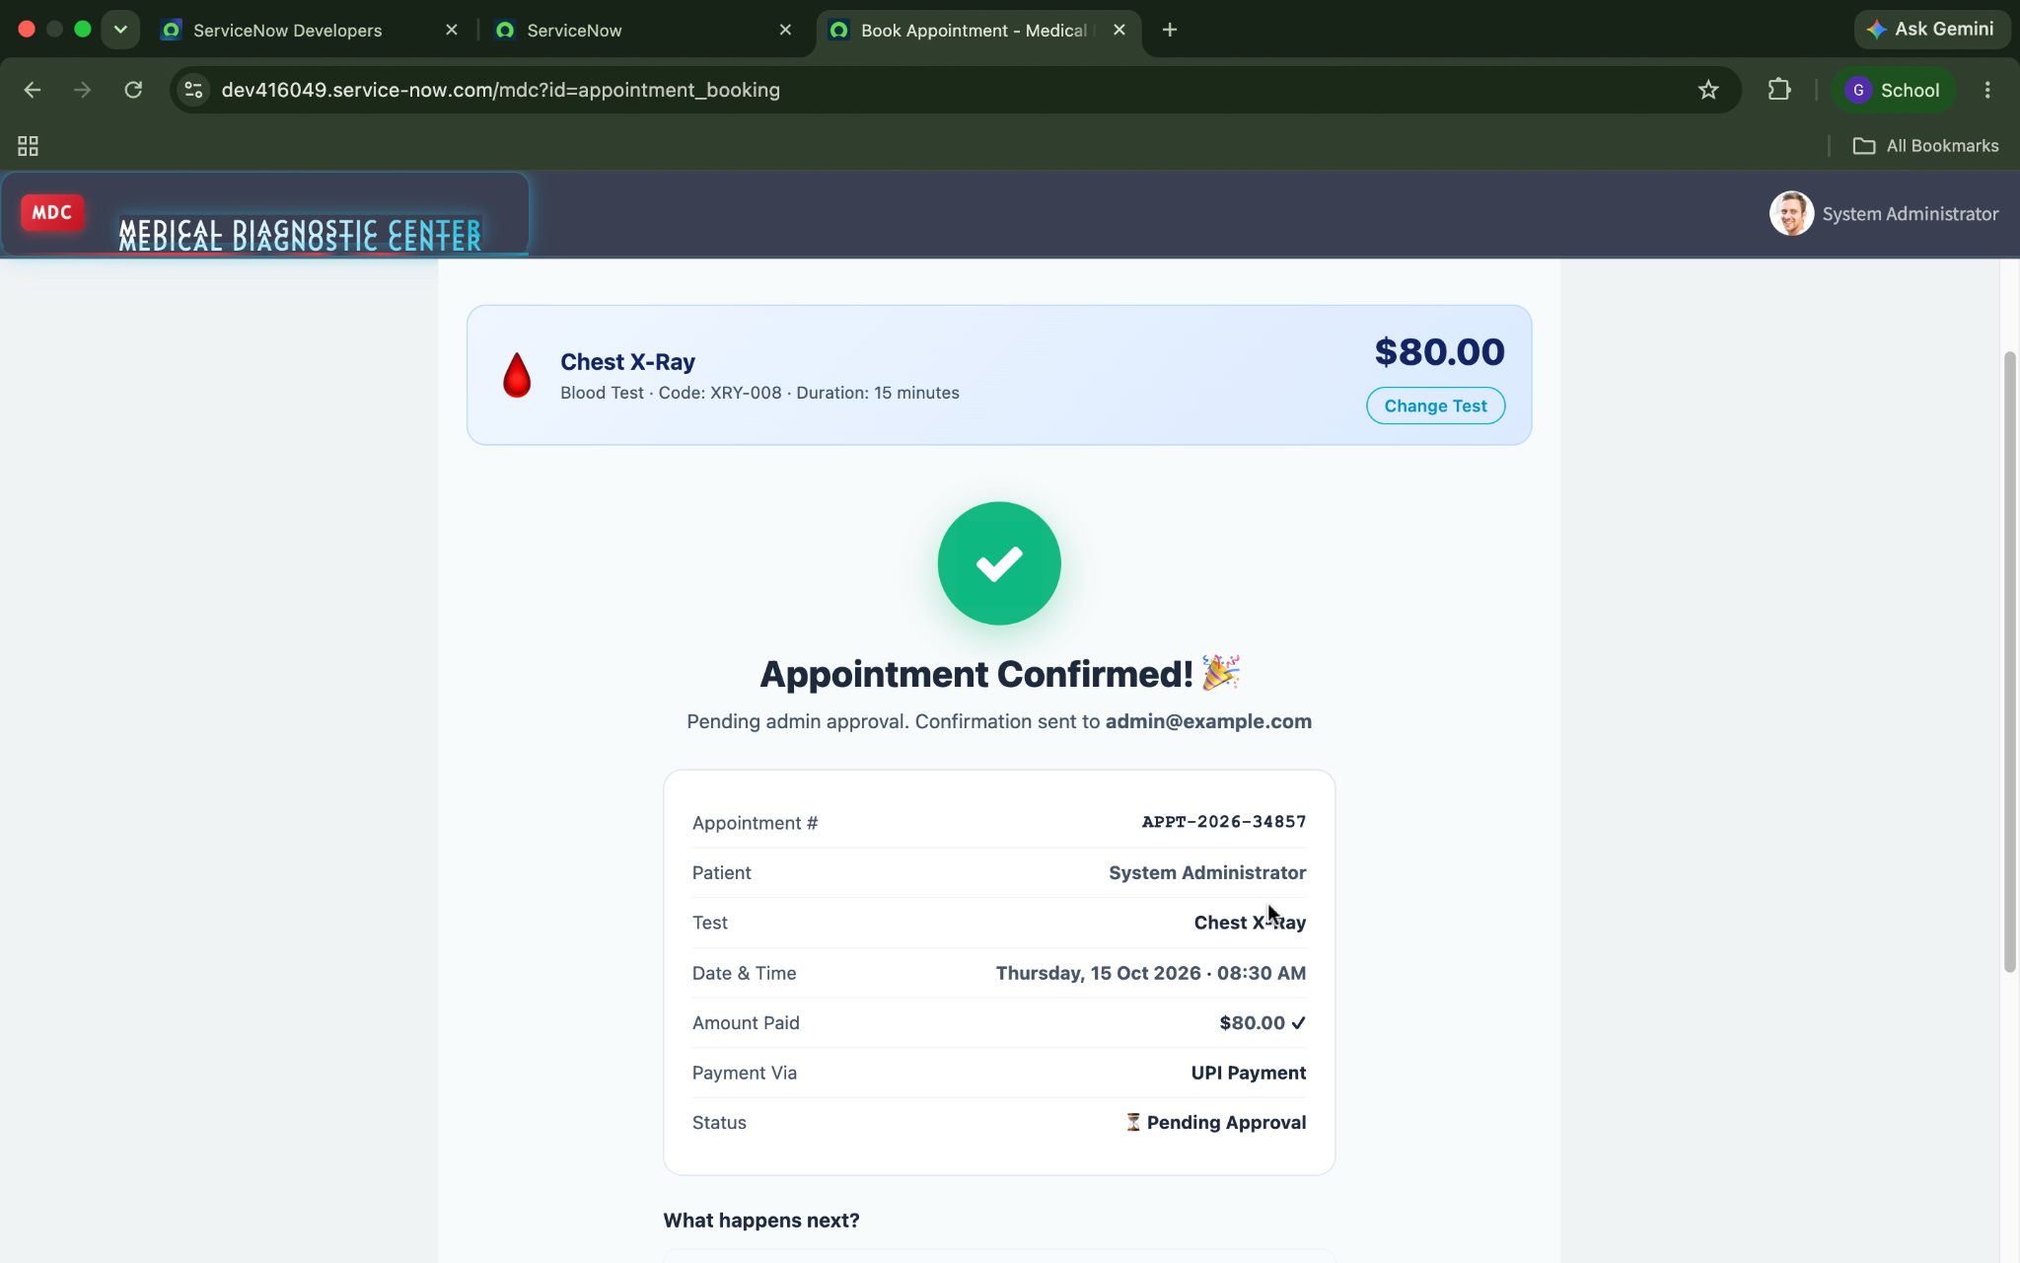

Figure 7. Appointment record with Completed status
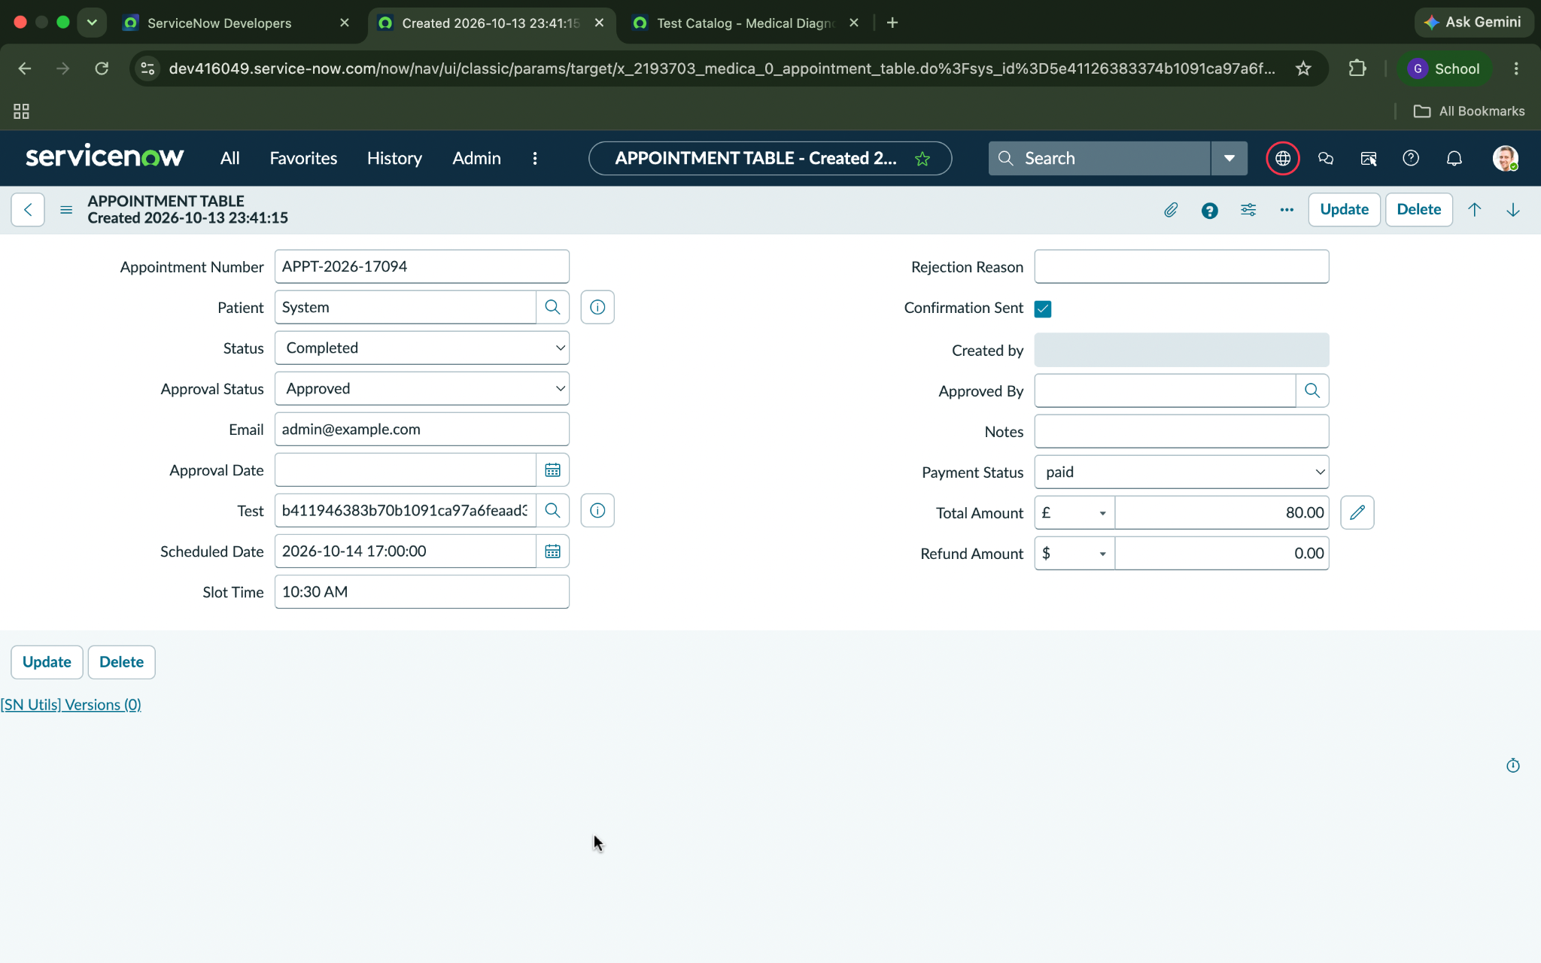

Figure 8. Medical Report record showing findings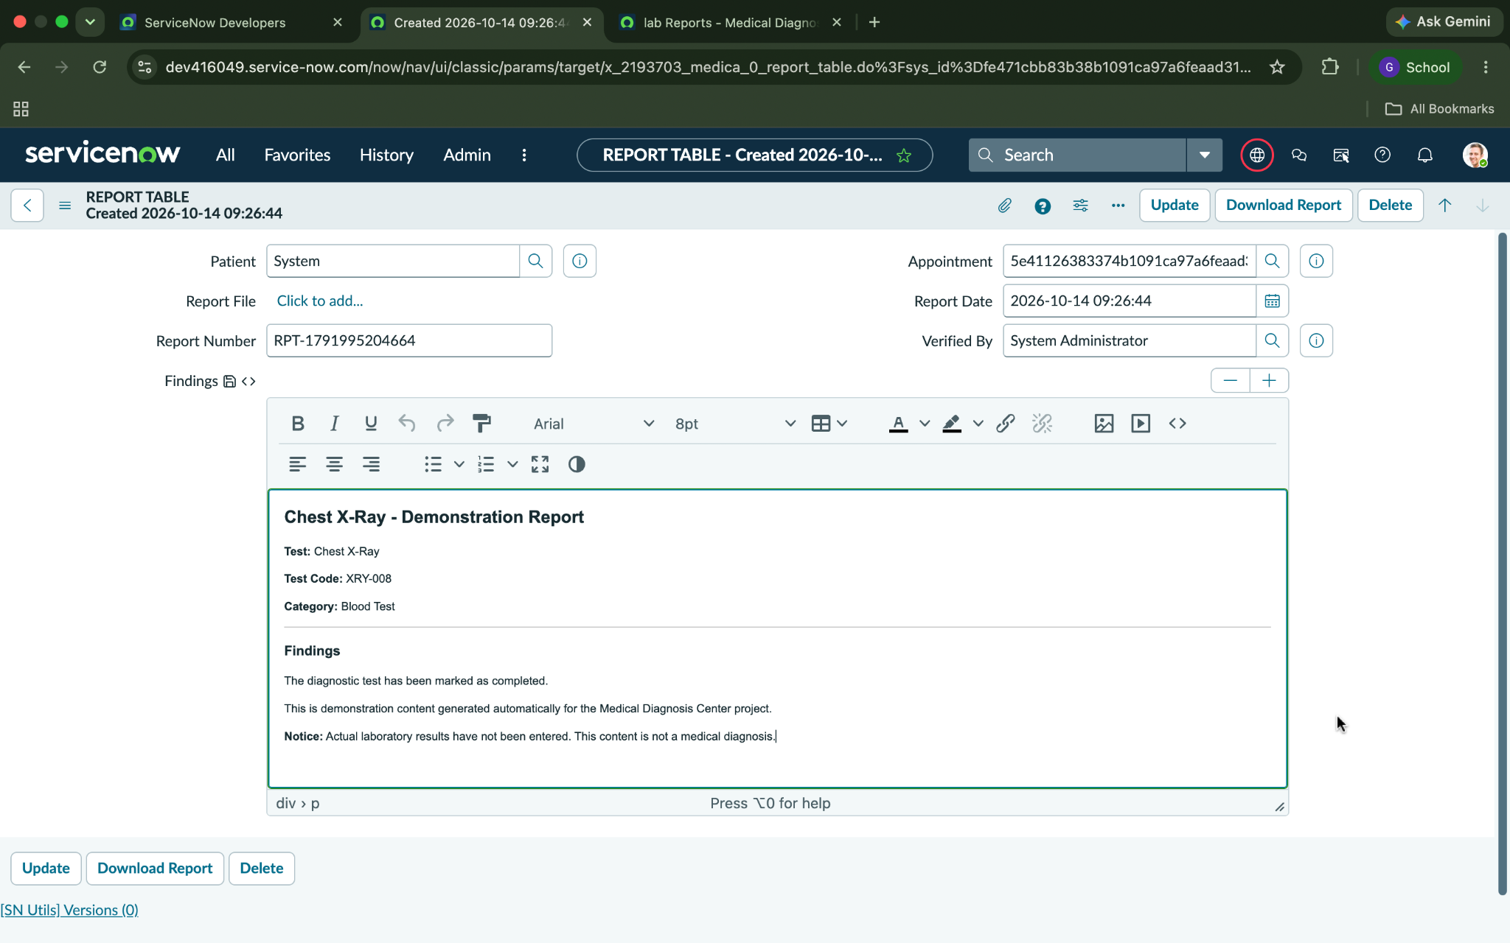

Figure 9. Medical Reports portal page
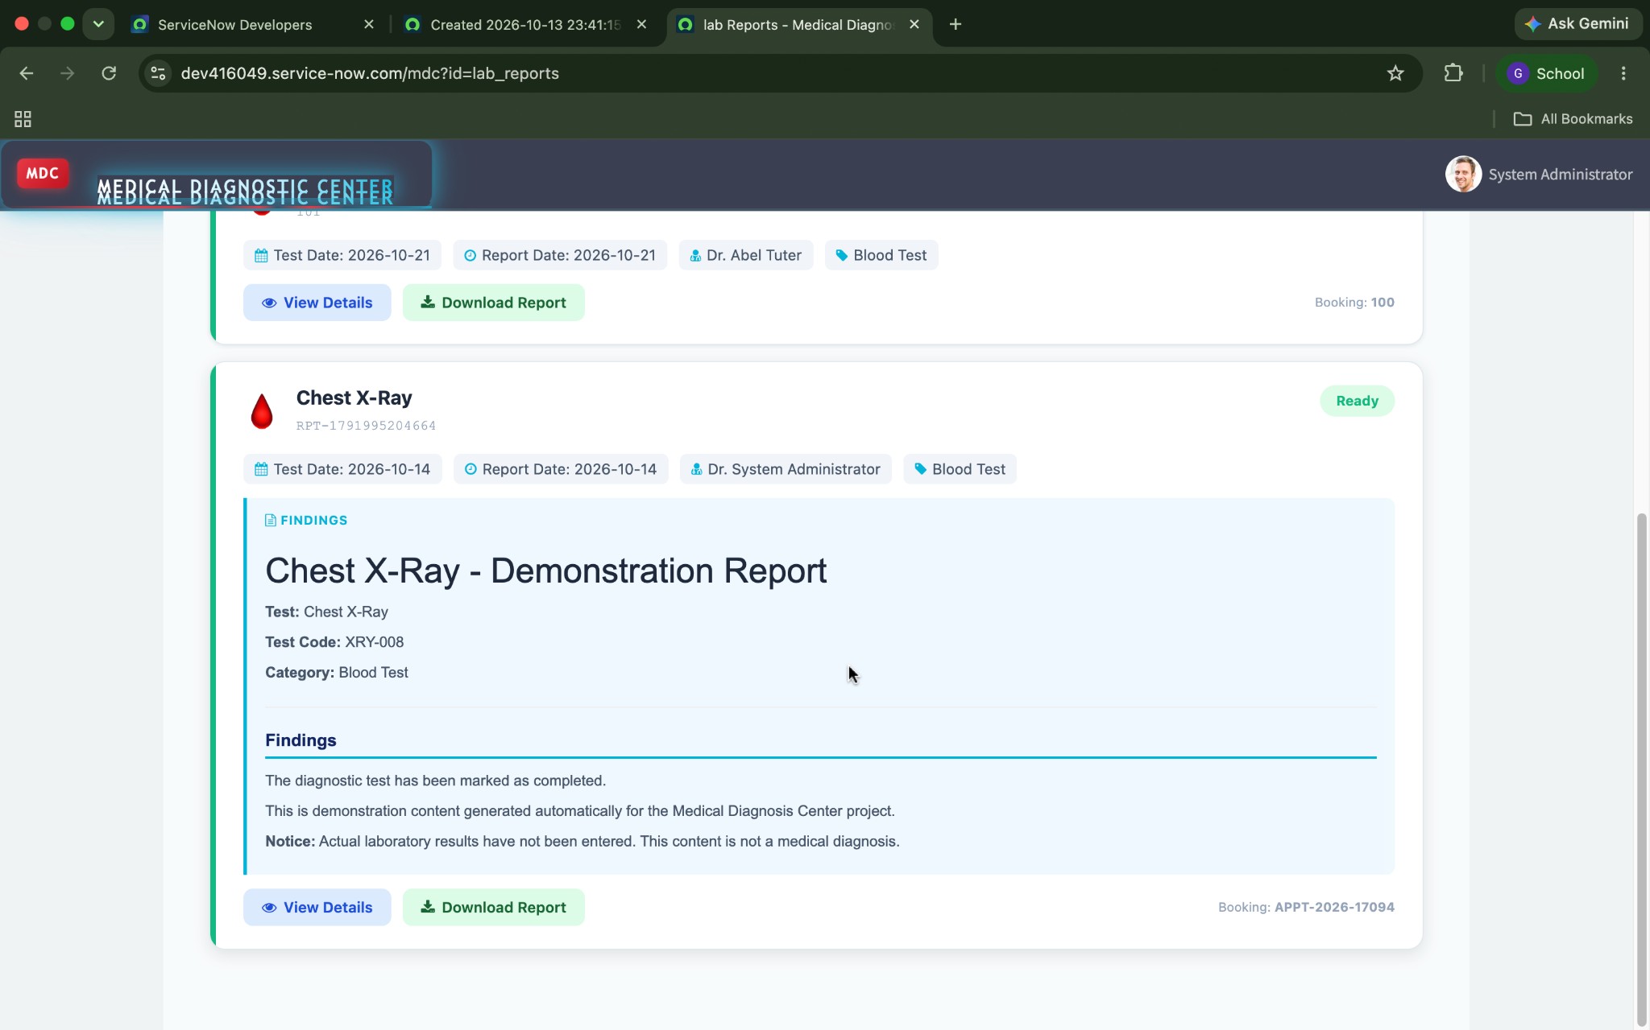

Figure 10. Download / Print Report output

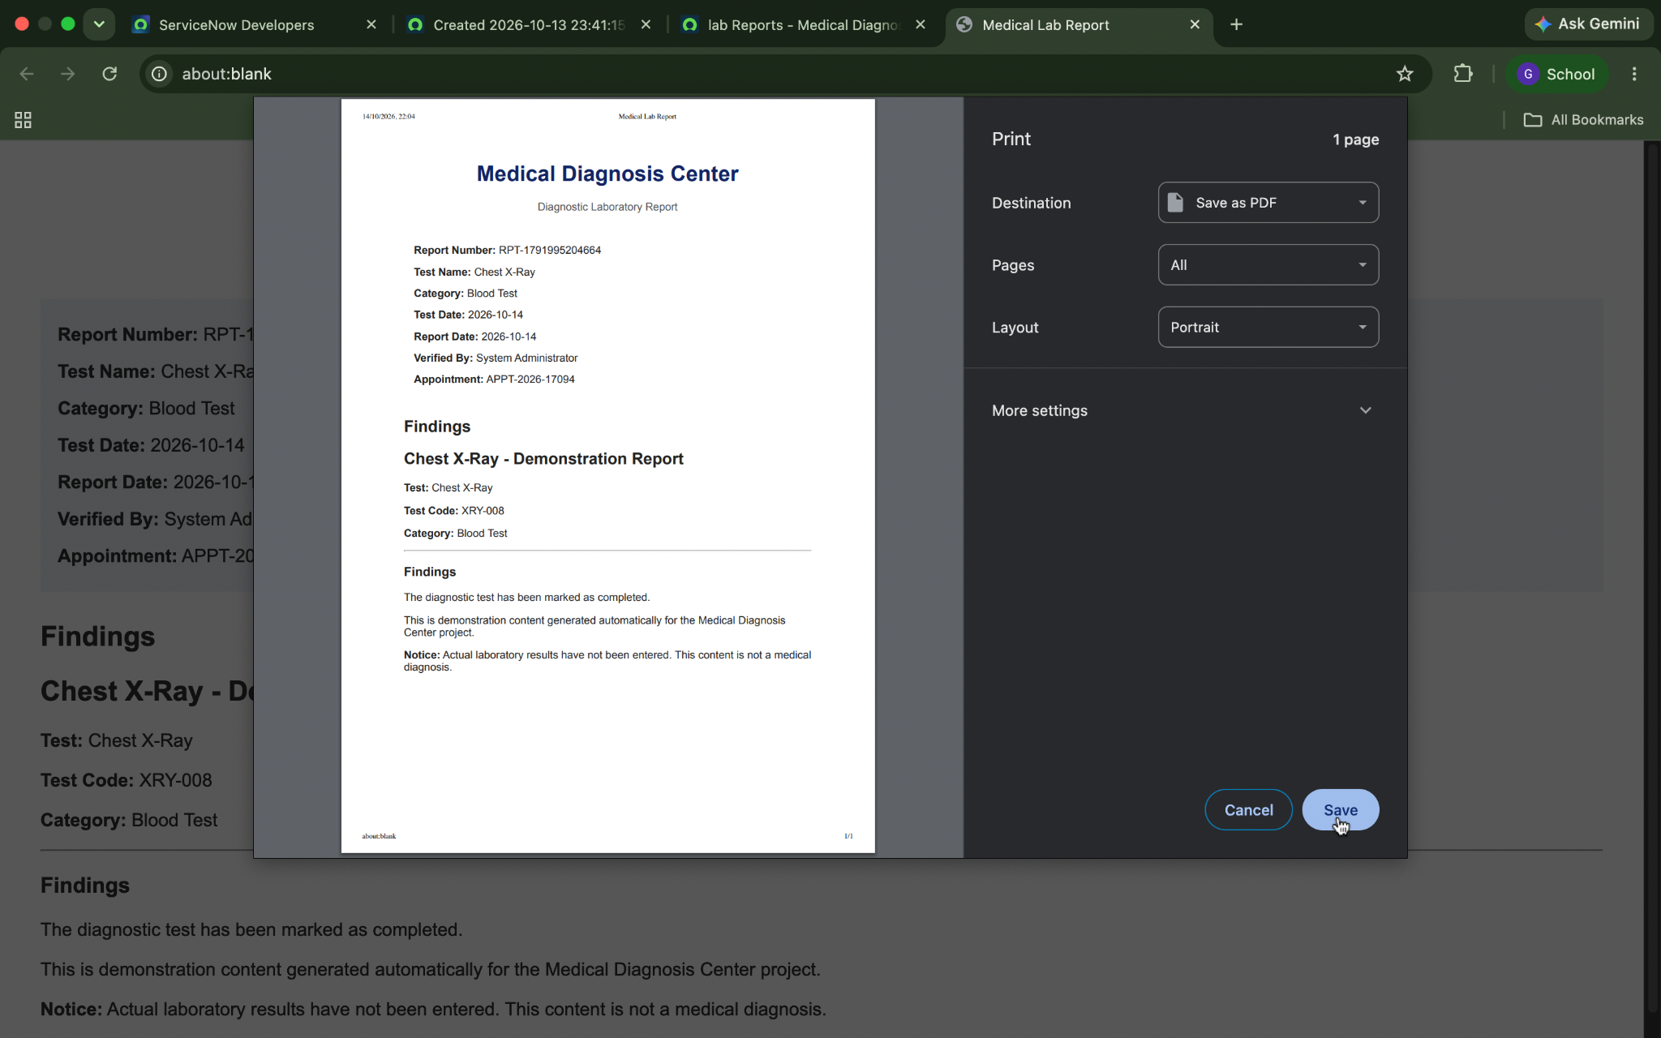

Figure 11. Email Notification

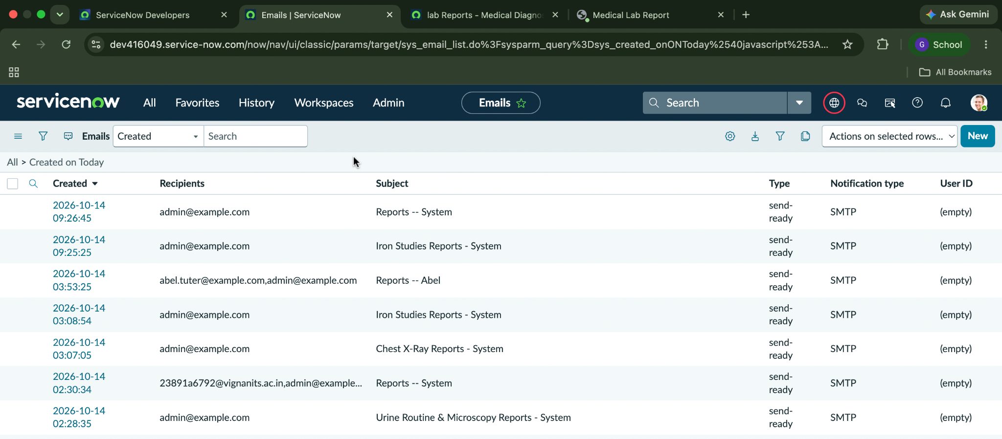

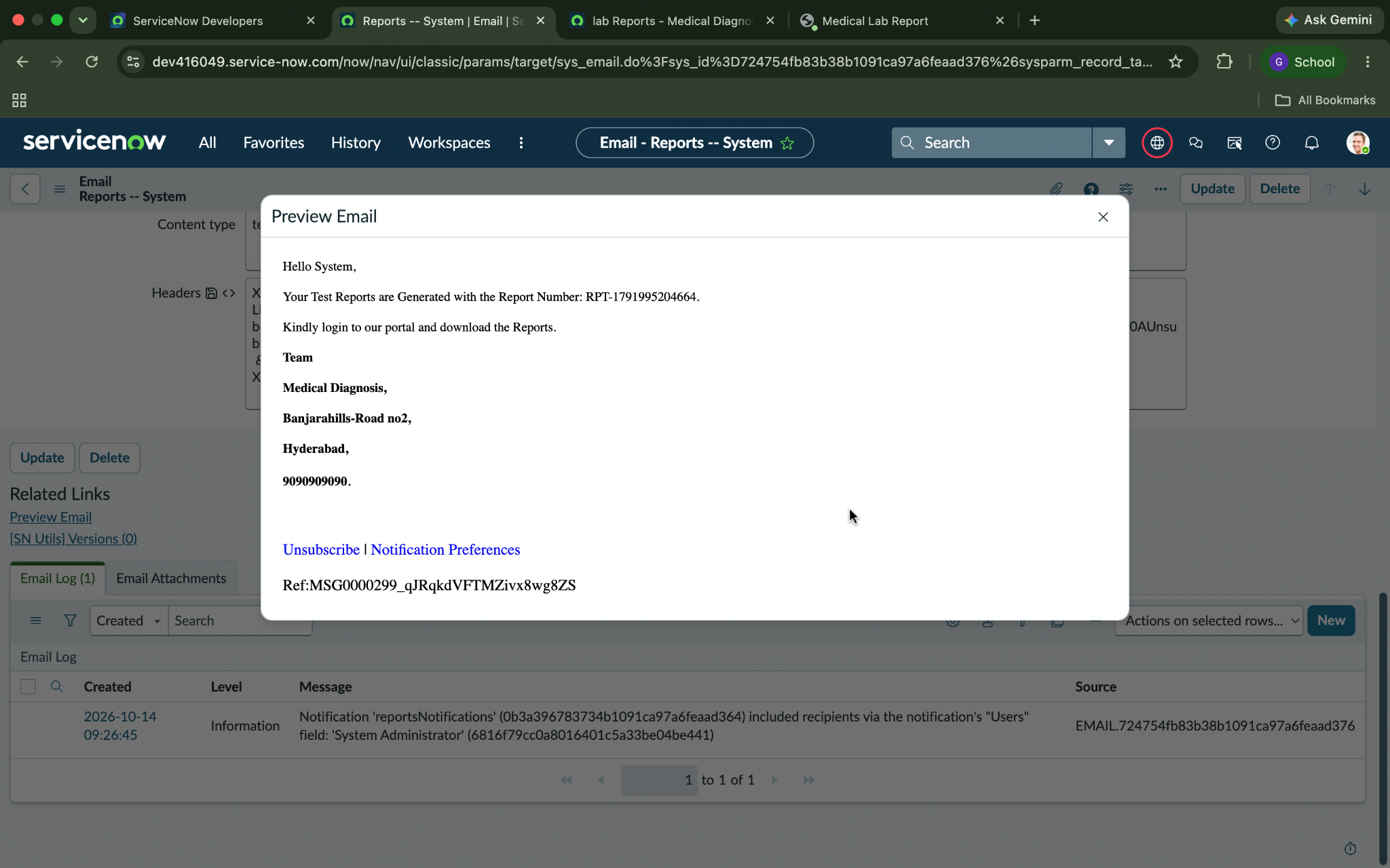

Figure 12 . Dashboard
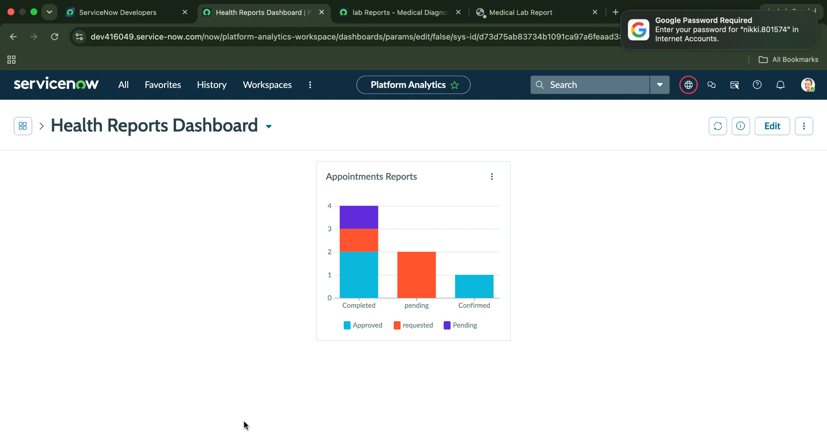

12. Known Issues and Development Considerations
The following points are useful to review when maintaining or extending the application, as configuration mismatches in ServiceNow can prevent widgets and automation from working as intended.
- Appointment time-zone mismatch: a selected appointment time may differ from the saved or displayed time. Check the instance and user time-zone settings and review how date-time values are passed between client-side and server-side scripts.
- Application table prefix: use `x_2193703_medica_0` consistently in GlideRecord queries. A different prefix can cause a query to target a nonexistent table or return no records.
- Internal field names: scripts must use field names rather than relying on the labels shown on forms. Confirm field names and reference-field configuration in the table definition before writing or modifying scripts.
- Choice values and labels: Business Rules should compare the stored choice value, not just the display label. A mismatch can prevent a status-based condition from running.
- Business Rule timing and duplicate records: verify the rule's table, timing, and conditions. Test repeated updates to a completed appointment to ensure report records are not created more than once unintentionally.
- Reference relationships: confirm that patient, diagnostic test, appointment, and report references point to the correct tables. Incorrect references can lead to missing related information in the portal.
- Widget server/client coordination: when a page fails to load data or a form submission does not create a record, inspect both the widget's client controller and server script, along with relevant instance logs.
- Access control: ensure that patient-specific data is filtered and protected on the server side. Hiding a link or page element is not sufficient to protect a record.

13. Future Enhancements
- Integrate with external hospital information systems and electronic health record platforms through suitable healthcare interoperability standards.
- Introduce digital signatures and report authenticity verification for approved reports.
- Add barcode or QR-code specimen identification to improve sample traceability throughout laboratory processing.
- Support multiple diagnostic center branches with centralized administration and branch-specific operations.
- Integrate billing and insurance workflows for payment reconciliation and claim processing.
- Explore AI-assisted result analysis to flag unusual patterns for review by qualified healthcare professionals, without replacing clinical judgment.
- Develop a dedicated mobile application or improved mobile experience for accessing appointments and reports.
- Introduce production-grade monitoring, backup, disaster recovery, and performance testing to improve reliability and scalability.

